1.Install MySQL Workbench on your computer, connect to the local MySQL server, and take a screenshot of the default databases shown in the Schemas panel.
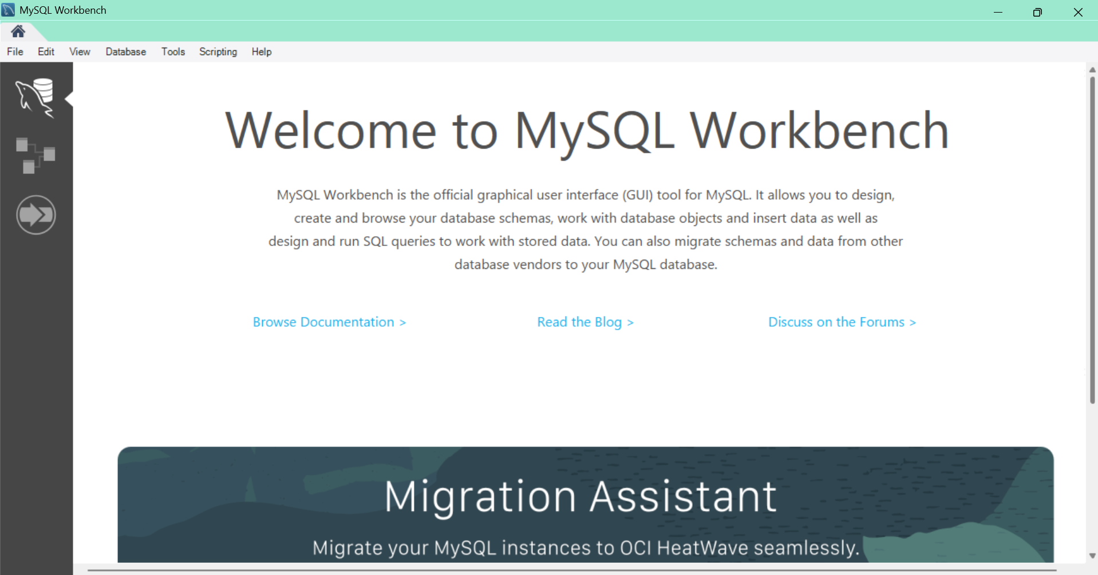
----------------------------------------------------------------------------------------------------------------------------------------------------------------------------------------------
2.Create a new database called InstaClone in MySQL Workbench, then create a table named Users with columns: user_id (INT, primary key), username (VARCHAR), email (VARCHAR), and followers_count (INT).

CREATE DATABASE InstaClone;

USE InstaClone;

CREATE TABLE Users (
user_id INT PRIMARY KEY,
username VARCHAR(50),
email VARCHAR(100),
followers_count INT
);
----------------------------------------------------------------------------------------------------------------------------------------------------------------------------------------------

3.Insert 3 sample users into the Users table you created, using realistic Instagram-style usernames and follower counts.

INSERT INTO Users
(user_id, username, email, followers_count)
VALUES
(1, 'priya_physics', 'priya@example.com', 1250),
(2, 'rahul_clicks', 'rahul@example.com', 3480),
(3, 'isha_creates', 'isha@example.com', 920);
----------------------------------------------------------------------------------------------------------------------------------------------------------------------------------------------
4.Create another table in the InstaClone database called Posts with columns: post_id (INT, primary key), user_id (INT), caption (VARCHAR), and post_date (DATE). Add a foreign key from Posts.user_id to Users.user_id to establish a relationship.

USE InstaClone;

CREATE TABLE Posts (
post_id INT PRIMARY KEY,
user_id INT,
caption VARCHAR(255),
post_date DATE,
FOREIGN KEY (user_id) REFERENCES Users(user_id)
);

----------------------------------------------------------------------------------------------------------------------------------------------------------------------------------------------
5.Write a short comparison (3-4 lines each) of MySQL, PostgreSQL, Oracle, and SQLite, focusing on where each one is commonly used (for example: web apps, mobile apps, enterprise systems, etc.).

A. MySQL
- MySQL is an open-source relational database management system.
- It is commonly used for websites, web applications, and e-commerce platforms.
- It is popular with applications built using PHP, Python, and Java.
- It is suitable for applications that need to store and retrieve structured data efficiently.

B. PostgreSQL
- PostgreSQL is an open-source relational database management system.
- It is commonly used in complex web applications, data analysis, and geographic information systems.
- It supports advanced SQL features, complex queries, and custom data types.
- It is suitable for applications that require strong data integrity and flexibility.

C. Oracle Database
- Oracle Database is a commercial relational database management system.
- It is commonly used in large enterprises, banks, government organizations, and financial systems.
- It provides advanced security, backup, recovery, and transaction management features.
- It is suitable for large-scale applications that require high availability and reliability.

D. SQLite
- SQLite is a lightweight, file-based relational database management system.
- It is commonly used in mobile applications, desktop software, and embedded systems.
- It does not require a separate database server to operate.
- It is suitable for small applications and local data storage, such as databases in Android apps.

